**Project 2 Proposal:**

**Energy Consumption in the United States**

We have chosen to analyze energy consumption in the United States to determine which states consume the most energy and where energy production is the highest. We were interested in analyzing this because of the concept of energy management.

There is a global need to save energy and the analysis on energy consumption determines energy prices, emission targets, and legislations. Monitoring and implementing a results-driven approach is an effective tool in energy management. Most of the principles that apply to businesses and other organizations are also applicable to homes.

With more research, we were able to find a study that lists a four-step process that is applicable to home energy management. Residents can meter their energy consumption and collect the data, find and quantify opportunities to save energy, and target the opportunities to save energy. Energy management is a complex concept, which is what intrigued us on choosing this as a topic for this project.

**Datasets:** <https://www.eia.gov/state/seds/data.php?incfile=/state/seds/sep_sum/html/rank_pr.html&sid=US&sid=DC>

<https://www.eia.gov/state/seds/seds-data-complete.php#PricesExpenditures>

**“Inspiring” Visualizations:**

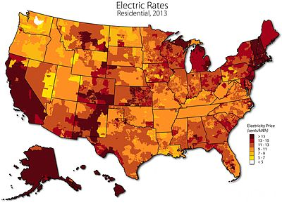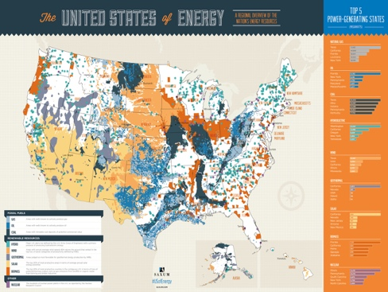

**Sketch of Final Design:**



**GitHub Repository:** https://github.com/smelaku/Project-2-Energy

**Group Members:** Caylon Thomas, Eyob Gebrerufael, Chris Cook, Selamawit Melaku